# readpermits.php

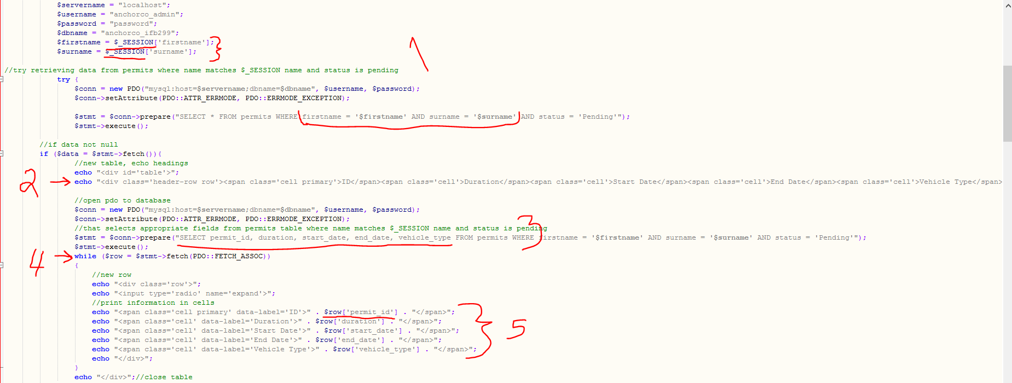

Step 1:

Check that there is data to retrieve using the $_SESSION name variables as filters in the SQL query

Step 2:

If data is returned, then create the headings for the table

Step 3:

Extract the desired fields from the database, according to $_SESSION name

Step 4:

Loop through each ‘row’ of data from the database

Step 5:

Display each variable in the row in table cells